Eat, Drink, and Be Merry

Pirkei Avos 2:15
R. Eliezer said: ...repent one day before your death...

Talmud, Shabbos 153a
Rabbi Eliezer said: Repent one day before your death. Rabbi Eliezer’s students asked him: But does a person know the day on which he will die? He said to them: All the more so one should repent today lest he die tomorrow; and by following this advice one will spend his entire life in a state of repentance.
And King Solomon also said in his wisdom: “At all times your clothes should be white, and oil shall not be absent from upon your head” (Koheles 9:8).

#1
Pirkei Avos 2:15
R. Eliezer said: ...repent one day before your death...

Question: Why does he suggest to repent one day before the death and not just because you sinned - which is usually the reason to repent?

Why day before and day of death?

#2
Talmud, Shabbos 30a
What is the meaning of that verse which (king) David said: “Lord, make me to know my end, and the measure of my days, what it is; let me know how short-lived I am” (Psalms 39:5)?
It means that David said before the Holy One, Blessed be He: Master of the Universe, Lord, “make me to know my end” - in how long will I die? G-d said to him: It is decreed before Me that I do not reveal the end of the life of flesh and blood. He asked further: “And the measure of my days” - on what day of the year will I die? He said to him: It is decreed before Me not to reveal the measure of a person’s days. Again he requested: “Let me know how short-lived I am” - on what day of the week will I die? He said to him: You will die on Shabbat.

Question: Why aren't we told when our deaths will occur? Why is it kept so secret?

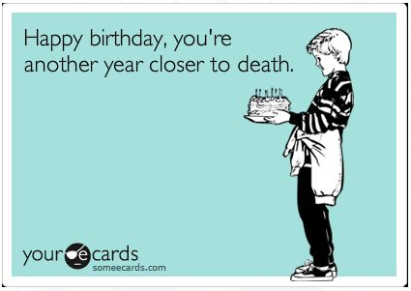
#3
Koheles 7:2
It is better to go to a house of mourning than to go to a house of feasting, since this is the fate of all man.

Question: Would constant thought about death ( i.e. today might be your last day) not make a person depressed and therefore less motivated to act and work on himself? Wouldn’t this bring the opposite effect of what the Mishnah is trying to accomplish, which is to encourage him to become a better human being and Jew?
Or maybe - the opposite - the thought of death will cause him to take life lightly, as the saying goes, “Eat, drink and be merry for tomorrow you may die.”

#4
News agencies keep dozens of potential obituatries on hand at all times – biographical sketches of important local residents — because in case anyone important dies suddently, the paper will be ready immediately with a thorough, well-written exposition of their life and accomplishments.

Questions:
Would you like to read your own obituary?
What would you want to be written there?
What would you want to be written on your tombstone?
Do you see any benefit from this exercise?

#5
Rabbi Noah Weinberg, founder of Aish HaTorah
If you don't know what you're willing to die for, then you don't know what you're living for.

Explain!

#6
Question: What’s your takeaway from today’s discussion?

